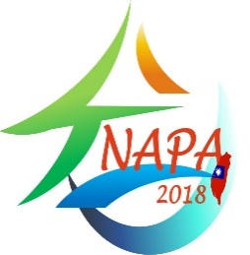
9th International Conference on Nutrition
and Physical Activity (NAPA2018)
December 17-19, 2018
Hotel National, Taichung, Taiwan
Abstract submission deadline Oct 15, 2018
Abstract Form
Title:
1st Author^{1,}*, 2nd Author², 3rd Author³, …..

¹ 1st author's affiliation, address incl. country code; ² 2nd author's affiliation, address, incl. country code; ….
*Corresponding author's E-mail address: …..

ABSTRACT

The word counts for the abstract is not more than 200 with Times New Roman font (size 12)

Keywords:
Keyword1, keyword2, …. (3-5 keywords)
Note: Please underline the presenting author, and
choice you would like to attend and present (□ Oral or □ Poster).
Filled in abstract form should be emailed to biochemkamesh@gmail.com or Napataiwan2018@gmail.com (before Oct 15th 2018).

